Please see other files in folder for my code and the original pdf of the plots

My four conclusions:

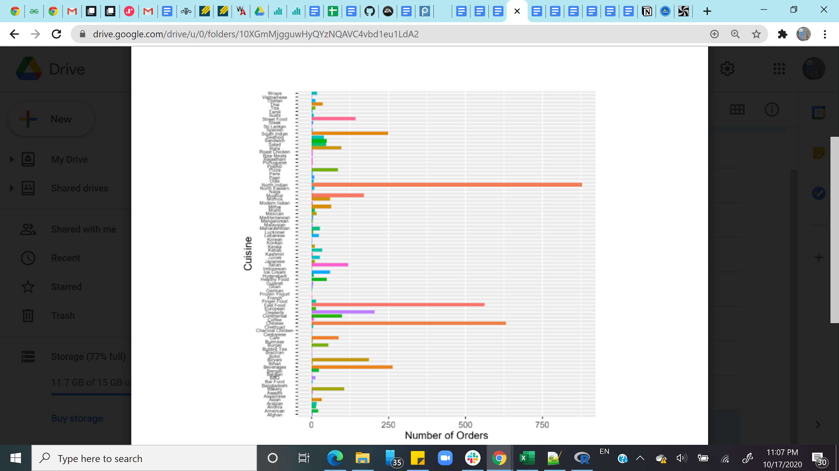

1. North Indian, Fast Food, and Chinese are the three most ordered cuisines.

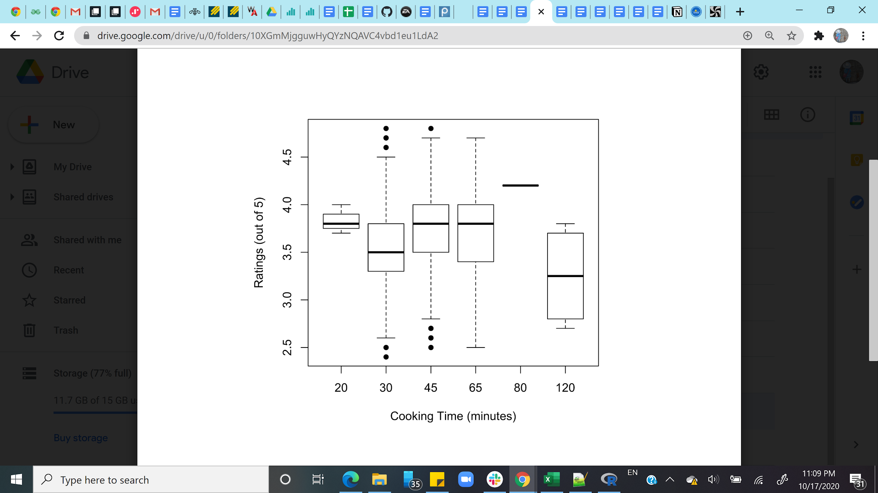

1. There are significant differences in ratings depending on cooking time based on the kruskal-wallis test. There is not a consistent trend, but the orders with 120 min cooking times had significantly lower ratings.

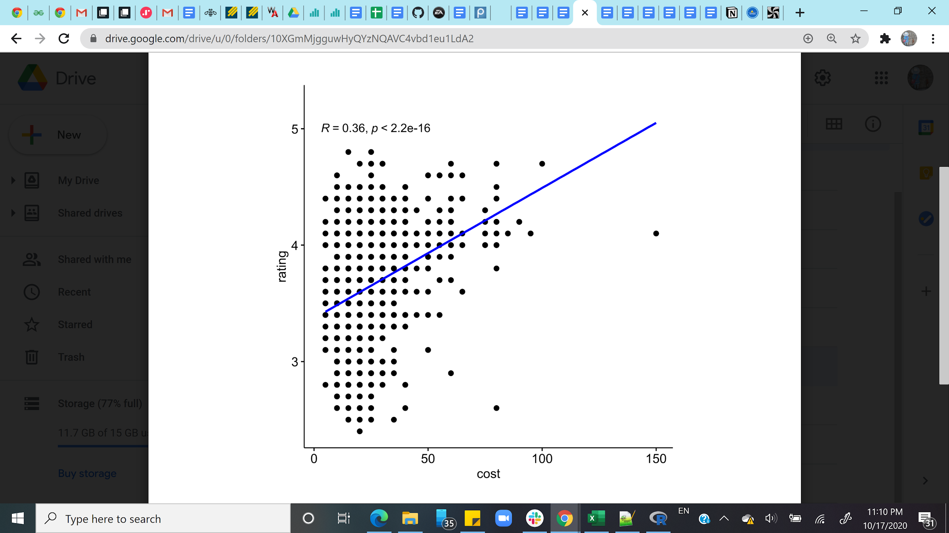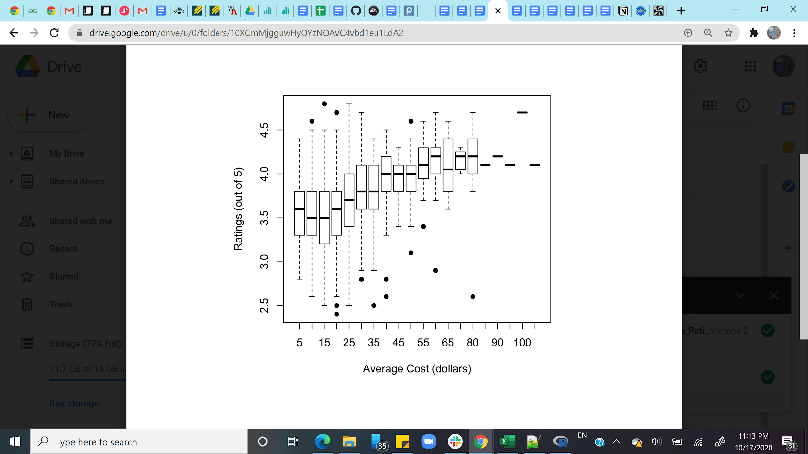

1. There are significant differences in ratings depending on average cost based on the kruskal-wallis test. There seems to be a consistent trend of higher ratings for higher average cost. Thus, a pearson’s correlation test was performed, and these results also verified that this correlation was significant.

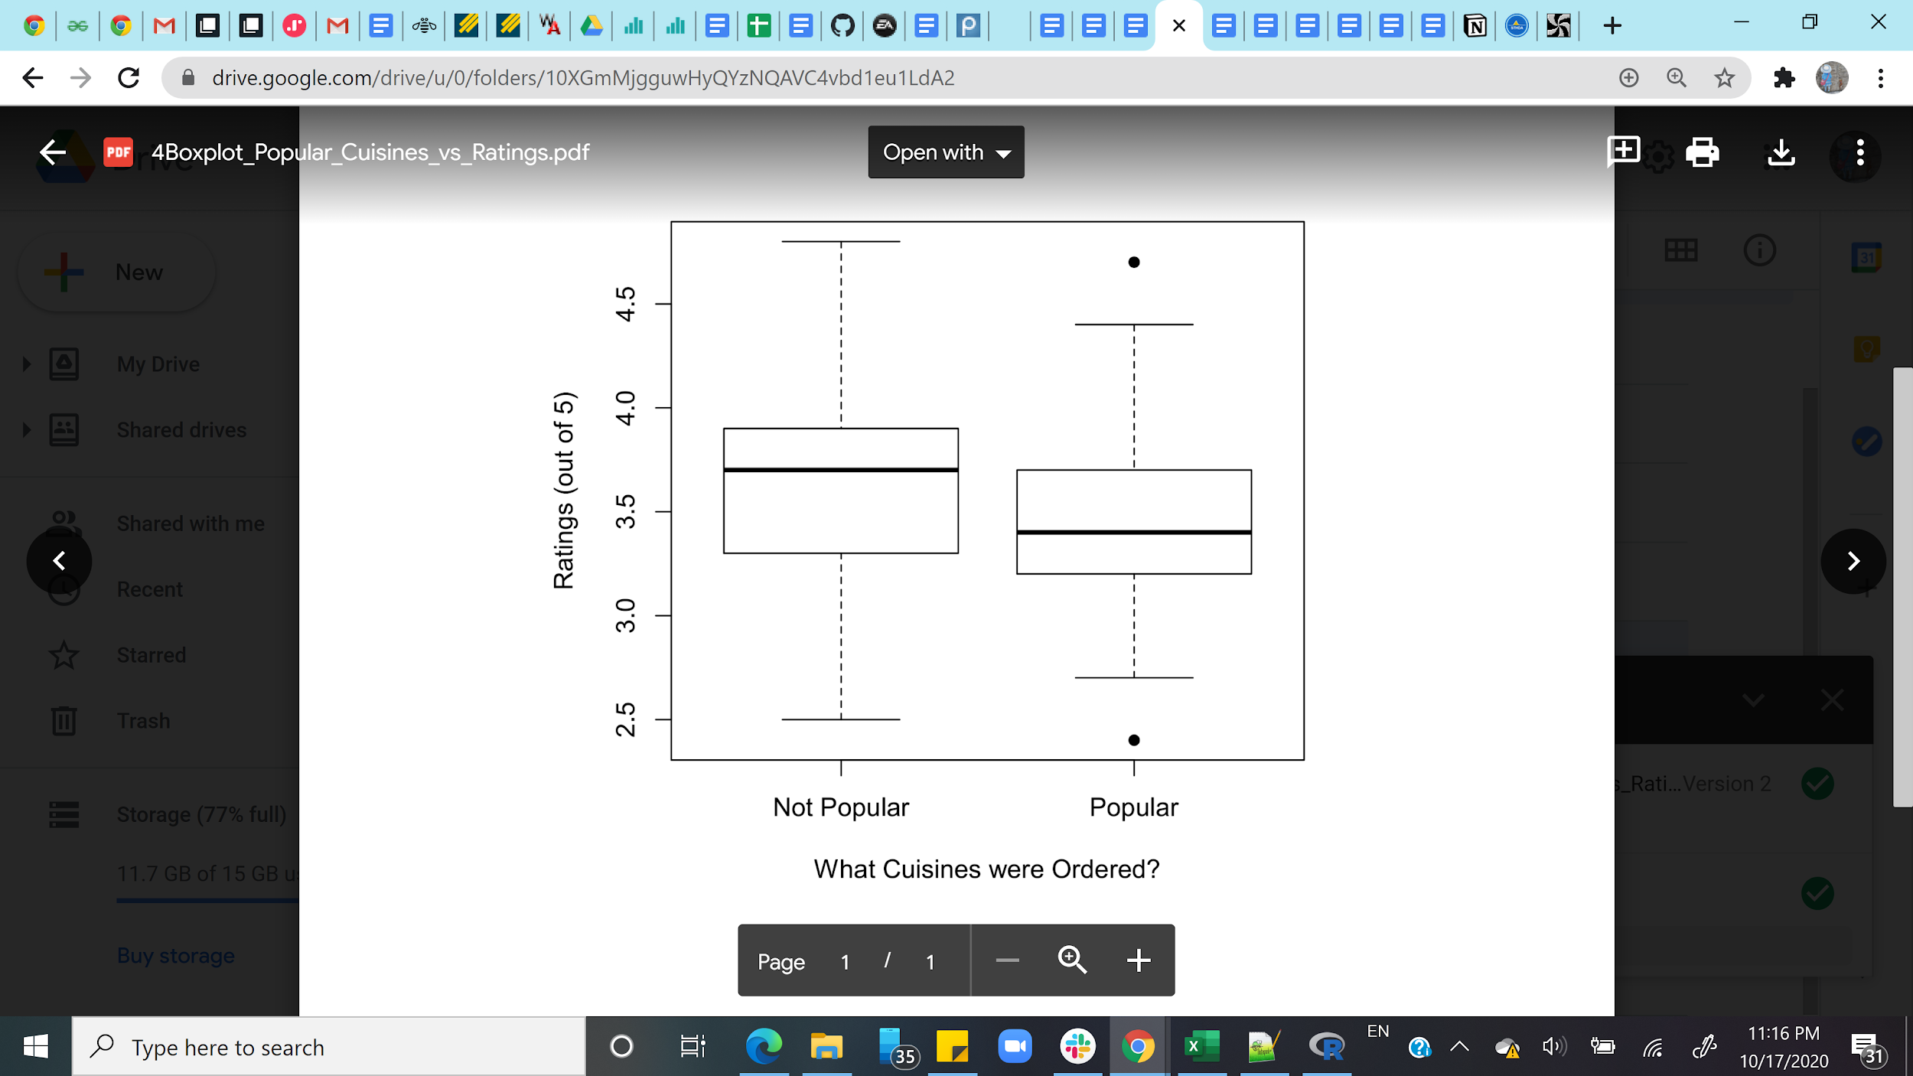

1. Contrary to my expectations, orders containing any one of the three most popular cuisines (North Indian, Fast Food, and Chinese) had significantly lower ratings (using the kruskal-wallis test) than orders that did not include these cuisines.